**DIU Robotics Club**

Dhaka International University

Email: diuroboticsofficial@gmail.com

**Date**: 12th October 2025

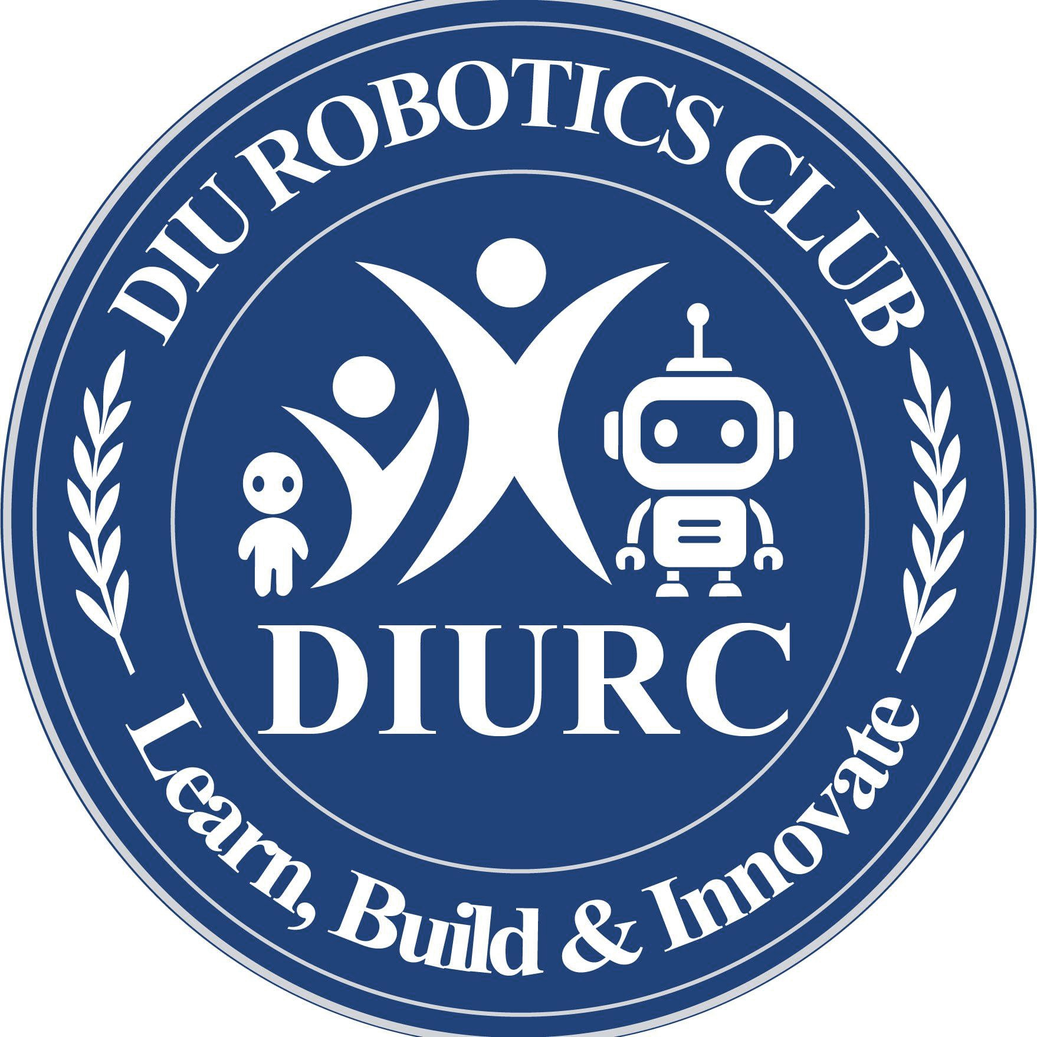**Subject**: Invitation to Webinar on “**Build Your First Autonomous Robot**”

Dear Sir,

Assalamu Alaikum,

We are pleased to inform you that the **DIU Robotics Club** has organized a webinar titled “*Build Your First Autonomous Robot*”. The session is designed to introduce participants to robot design and simulation using Proteus software.

**Details of the Webinar:**

● **Topic:** Build Your Robot on Proteus

● **Date:** 10th September 2025

● **Time:** 9:00 PM

● **Room:** 602

● **Speaker:** Md. Rasel Islam, Convener, DIU Robotics Club

We would be honored by your gracious presence in this program. Your participation will inspire and energize our members and attendees.

Thank you for your kind attention.

With best regards,

**DIU Robotics Club Committee 2025**

Dhaka International University

📧 diuroboticsofficial@gmail.com